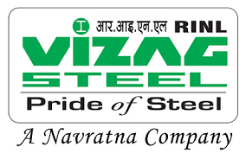

VISAKHAPATNAM STEEL PLANT

**RASHTRIYA ISPAT NIGAM LIMITED**

TECHNICAL TRAINING INSTITUTE DEPT

# A Project Report On

***"A PROJECT ON COMPUTERISED RAWMATERIALS MANAGEMENT SYSTEM USING HTML''***

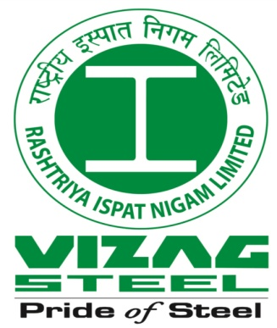

In Partial Fulfillment for Trade Apprenticeship Training

**“COMPUTER OPERATOR AND PROGRAMMING ASSISTANT” (COPA)**

# Under the guidance of

**Shri. Dipankar Dey, Dy.Manager (Trg).**

Submitted by

K.ESWARUDU

TRAINEE NO: 052544

(BATCH-2021-22)

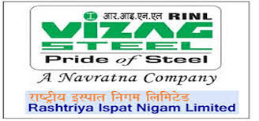

**CERTIFICATE**

This Is To Certify That The Project Work Entitled **“A PROJECT ON COMPUTERISED RAWMATERIALS MANAGEMENT SYSTEM USING HTML”** Technical Training Institute, Visakhapatnam Steel Plant, **Rashtriya Ispat Nigam Limited, Visakhapatnam**” Is Done By **K.ESWARUDU,** (**COPA)** Trainee, In Partial Fulfillment Of The **COMPUTER OPERATOR AND PROGRAMMING ASSISTANT (COPA)** Trade Apprenticeship Training During **1st October 2021 To 30th September 2022.**

DATE:

PLACE:

Signature of Project Guide

**ACKNOWLEDGEMENTS**

I express my sincere gratitude and in debtedness towards my training & project guide **Shri. DIPANKAR DEY, Dy.Manager (TRG)**, for his inspiration, encouragement, assistance & guidance in carrying out the project work without which have been possible on my part to complete the project work in time.

I am highly obliged for the kind cooperation extended by our

**Shri.** **TADI BHASKARA REDDY, Asst.Manager (TRG) .**

Also, i will be very thankful to **Shri.T.GOUTHAM, HOD (RMD)**, for his valuable guidance and support, in completing this project.

Special thankful to **Shri. S.SUDARSANA RAO, General Manager (RMD).**

Special thankful to **Shri. B.SankaraRao, Sr.Manager (RMD)**

Special thankful to **Shri. K.Brijendranath, Dy. Manager (RMD).**

Adding to them I would also like thank all the members of the Department for supporting me in each and every step during completion of my project.

**(K.ESWARUDU )**



**DECLARATION**

I hereby declared that project work entitled by **“A PROJECT ON COMPUTERISED RAWMATERIALS MANAGEMENT SYSTEM USING HTML”** in partial fulfillments of “**COMPUTER OPERATOR AND PROGRAMMING ASSISTANT (COPA)**, Trade Apprenticeship Training” is a bonafied work done by me under guidance of **Shri. DIPANKAR DEY, Dy.Manager (Trg)** Visakhapatnam steel plant to the best of my knowledge.

DATE:

PLACE:

**( K.ESWARUDU )**

**Trainee No:052544**

***Introduction***

***About the***

***“A PROJECT ON COMPUTERISED RAWMATERIALS MANAGEMENT SYSTEM USING HTML''***

*RAW MATERIALS DEPARTMENT*

*(RMD)*

***CONTENTS***

***SL.NO CAPTERS Page No***

1. *INTRODUCTION TO* ***STEEL PLANT*** : *1-7*
2. *ACTIVITIES OF*  ***LEARNING AND DEVELOPMENT CENTER :*** *8-11*

1. *INTRODUCTION TO* ***RAW MATERIALS DEPARTMENT*** : *12-26*
2. *ABREVIATIONS FOR* ***RAW MATERIALS DEPARTMENT*** : 27-28
3. *RAW MATERIAL DEPARTMENT USING IN* ***HTML PROGRAMME***: 29-38
4. ***CONCLUSION & DISCUSSION***: *39-40*

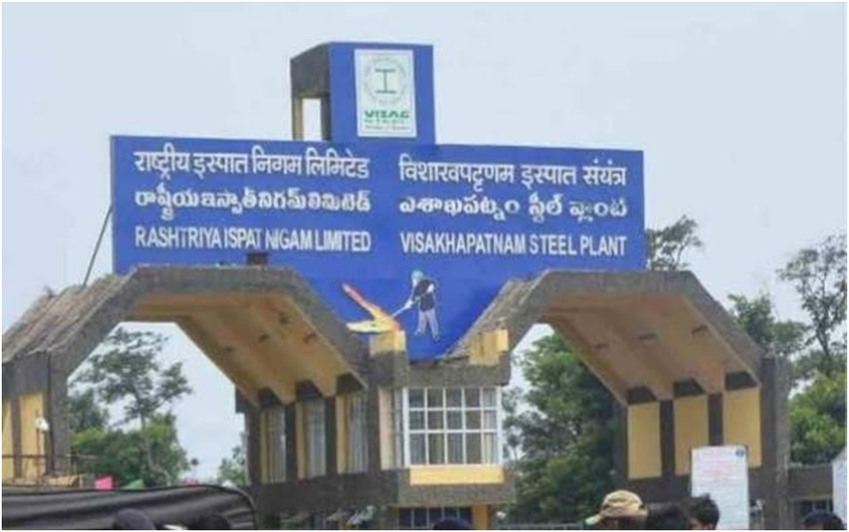***1. INTRODUCTION TO STEEL PLANT***

It is the first coastal based located 16km west of city of destiny that is Visakhapatnam. Bestowed with modern technologies, VSP has an installed capacity of 5.772 million tons of hot metal, 5.272million tons of crude steel, and 5.138 million tons of saleable steel. The total power required is 350MW.

The products of the Vishakhapatnam Steel plant are Rebars, Wire rod coils, plain rounds, structurals etc. The efforts of VSP have been recognized. Some of the major awards received by VSP so far are

1.  Priyadarshini Vrikshamitra award.

2.  Nehru memorial national award for pollution control.

3.  Golden peacock (first prize) National Quality Award.

4. World quality commitment award of Spain.

Visakhapatnam Steel Plant Popularly known as Vizag Steel, is an integrated steel producer India built using German and Soviet technology. The company has grown from a loss-making industry to 3-billion-dollar turnover company registering a growth of 203.6% in just four years.

Vizag Steel Plant was conferred  status on 17 November 2010. Founded in 1971, the company focuses on producing value-added steel, with 214,000 tones produced in August 2010, out of 252,000 tones total of salable steel produced.

## HISTORY:

## On 17 April 1970, the Prime Minister of India, the , announced the government's decision to establish a steel plant at Visakhapatnam. With the offer of assistance from the government of the erstwhile , a revised project evolved some years later. A detailed project report for a plant with a capacity of 3.4 Mtpa was prepared in November 1980 and in February 1981, a contract was signed with the USSR for the preparation of working drawings and . The blast furnace foundation was laid, with first mass concreting, in January 1982. The construction of the local township was also started at the same time In the 1970s, Kurupam Zamindars donated 6,000 acres of land for Vizag Steel Plant. A new company  (RINL) was formed on 18 February 1982. Visakhapatnam Steel Plant was separated from  and RINL was made the corporate entity of Visakhapatnam Steel Plant in April 1982.

## Vizag Steel Plant is the only Indian shore-based steel plant and is situated on 33,000 acres (13,000 ha), and is poised to expand to produce up to 20 MT in a single campus. Turnover in 2011-2012 was Rs 14,457  On 20 May 2009, Prime Minister launched the expansion project of Visakhapatnam Steel Plant from a capacity of 3.6 MT to 6.3 MT at a cost of Rs. 8,692 crores. But the investment was revised to 14,489 crores with the following classification

## Expenditure for the financial year 2009-10 Rs 1840 crores.

## Rs 5883 crores since inception of the project.

## Total commitment, including enabling works, steel procurement, consultancy, spares, etc. is Rs 11591 crores as of 25 March 2010.

## The expansion project is expected to become functional by 2012. Currently, the steel plant has completed the expansion from 3.6 MT to 6.3 MT with a total investment of Rs.12,300 crore.

## The company has planned to expand its production capacity further by one more MT which requires an investment of Rs.4,500 crore.

## G:\kumar\full work\photos\VIZAG-STEEL logo.jpg

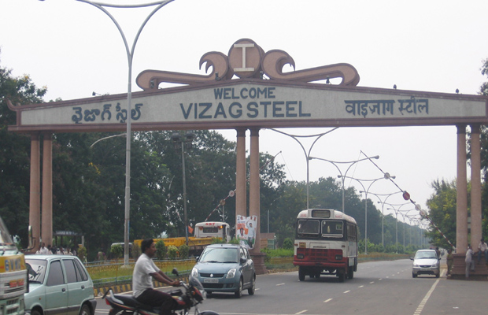

**Company profile:**

Rashtriya Ispat Nigam Limited, the corporate entity of Visakhapatnam Steel Plant is a Navaratna PSE under the Ministry of Steel. Visakhapatnam Steel Plant fondly called Vizag steel. It is the first shore based Integrated Steel Plant in the country and is known for its quality products delighting the customers. It is a market leader in long products and it caters to the needs of diverse Industrial sectors. It is the first Steel plant to be certified ISO 9001:2008 (presently2015), ISO 14001:2004 (presently2015), OHSAS 18001:2007 and ISO/IEC 27001:2013 Standards. It is also the first PSE to be certified ISO 50001:2011 - Energy Management Systems and has acquired CMMI Level 3 Certification for s/w development.

***VISION 2025***

**To be the most efficient Steel Maker having the largest single location shore based steel plant in the country.**

***OBJECTIVES***

* Achieve Gross Margin to Turnover ratio > 10%
* Plan for finishing mill to integrate with 7.3 MT capacity and commission the same by 2017-18.
* Achieve rated capacity of new & revamped units by 2017-18.
* Capture markets for high –end value added products by focusing on sector specific applications and customer needs.
* Globalisation of operations through acquisition of mines and setting up of marketing network abroad.
* Diversify through operationalizing of Bhilwara Mines, setting up of Pelletization Plant, DRI-EAF unit, Wheel & Axle Plants.
* Create high performance and safe work culture by nurturing talent and developing leaders.

* To grow in harmony with the environment & communities around us.

***CORE VALUES***

**I** **I**nitiative : Have a self-propelled & proactive approach.

**D D**ecisiveness : Decide with speed & clarity.

**E** **E**thics : Be consistent with professional & moral values

**A** **A**ccountability : Take responsibility for actions.

**L** **L**eadership : Lead by example

**S** **S**peed : Demonstrate swiftness and efficiency in everything we do.

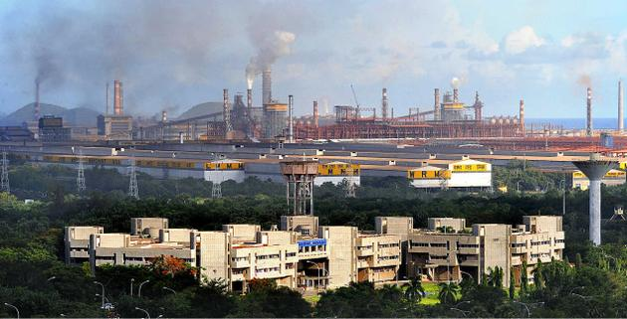

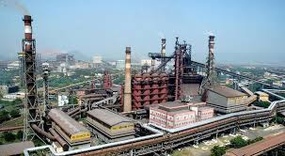

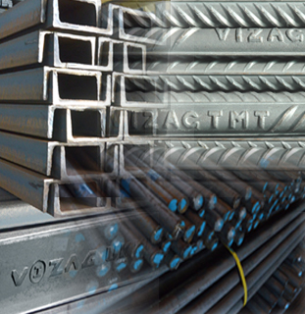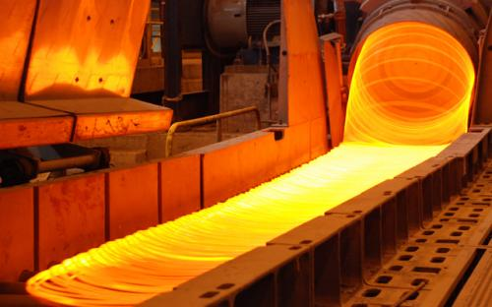**RINL PRODUCTS**

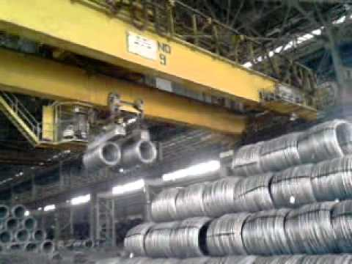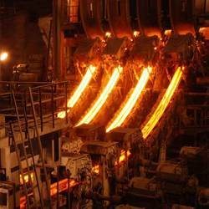

**RINL - PRODUCTS**

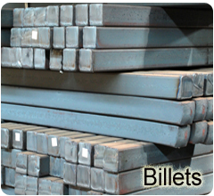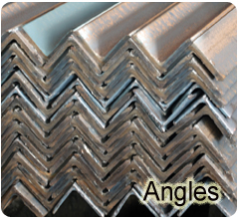

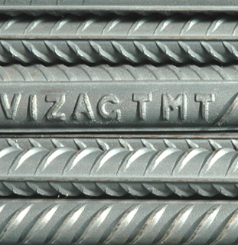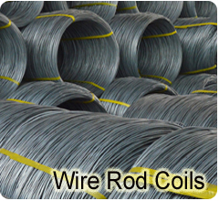

**2. ACTIVITIES OF LEARNING AND DEVELOPMENT CENTER**

1. Adopt a planned approach towards Training and Development in RINL.
2. Design and conduct suitable training package for freshers at various intake levels incorporating concepts of job enrichment and multiskill approach to work.
3. Design and conduct suitable training package for the employees as per need to develop skills, knowledge and attitude.
4. Assist in developing standard operating/maintenance practices for technological areas of the plant/unit.
5. To expose selected employees to latest technologies and workpractices abroad.
6. Motivate and develop internal training faculty.
7. Knowledge sharing and giving adequate opportunities to the employees for self-development.
8. To make training productive and cost effective.
9. Organise training of apprentices as per act obligations.
10. Constantly enrich the quality of training and upgrade training facilities to meet the requirement.
11. Providing training services to outside organisations.
12. To have interaction with academic institute
13. ions and fulfill social obligations**.**

### TRAINING OBJECTIVES

* Identifying training needs
* Providing training input
* Monitoring training effectiveness
* Creating learning environment
* Facilitating self-development
* Innovativeness & self-expression
* Enabling employees to assume higher responsibility
* Meeting the Statutory requirements & Social Obligations

**TRAINING SCHEMES:**

**Fresher’s Training:**

* VSP recruits Engineers, post Graduates in arts or science, Diploma holders, ITI Certificate holders a Management Trainee (Technicial), Management Trainee (Adman), Senior Trainees, Junior Trainees respectively. After imparting appropriate training they are regularized.
* Apprenticeship Training: Under the apprenticeship Act 1961, VSP is engaging Graduates in Engineering, Diploma holders and ITI Certificate holders and Intermediate Apprenticeship/ Regional Directorate of apprenticeship Training.
* **Remarks:**

No obligation by Industry to give employment and also no obligation on part of apprentice to serve the Industry on completion of training.

* **Vocational Training:**

Students studying degree in Engineering. Information Technology computer science, etc. are given facilities to do project work/ undergo training for a period of 2 to 8 weeks as per the requirement of their university / Institution. They work on Projects mutually beneficial to individuals as well as VSP. The requests for such training have to be given through the head of the institution. Training charges are payable to RINL by the students as per rules.

* **Employees Training:**

RINL is one the few organization where a definite HRD philosophy was evolved right forms its inception stage. Two training advisory committees with Divisional heads as members regularly monitor, review and guide training and Development activities. HRD policy was adopted in the year 2002 reflecting the organization vision, Mission and core values which flows corporate policies on HR, Quality, Occupational Health and safety, Energy and Environment. Every year about 20000 employees are trained in different.

* Technological,
* Skill development,
* Computer based,
* Refresher,
* Safety and Health related,
* On the job training programmes,
* Refresher training programs.
* Training need analysis is carried out to decide on the nature of training Programmers, no. of training programmers to be conducted in the financial year. Accordingly a calendar is prepared for the year. An on line information system called TRAINS (Training Information System) is in vogue to get the nominations form different departments, confirming the nominations and other training related activities.
* **Foreign Training :**

Some VSP employees based on the organization needs are sent abroad to gain specialized knowledge by attending training programmers, conferences, seminars, business trips etc. The whole activity is coordinated by TTI.

* **Training for other Organization:**

VSP is a turnaround company. It has become a role model to Indian Industries in many fronts, particularly Steel sector. Many organization look up to VSP to get trained their employees. We extend necessary training facilities to them on payment basis; this training consists of class room lectures as well as On-the-Job training.

* **Comprehensive Managerial Course:**

Is conducted for Non-unionized supervisory cad in three phases. Phase on (Induction Course) is of 6-9 days duration. Phase-2 (Foundation Course) is of 17 weeks –part time 6-8 PM. phase-3 (Specialized Course) is of 14 weeks-part time, 6-8 PM. This course consists of Technical and Non- Technical subjects.

* **TRADE TESTS:**

To facilitate career growth of employees. Trade Tests are conducted to assess the knowledge and skill. These Trade Tests are conducted for promoting the employees form Khalasis/Helper to Technician level and from Technician level to Charge man level based on the Trade Test specification. After promotion Non-unionized supervisory cadre employees undergo a Comprehensive Training to become eligible for Executive Cadre.

* **Classrooms :**

There are 6 Well furnished & Air conditioned class rooms, a conference hall and 10 class rooms.

* **Work Shop:**

A full- fledged workshop exists with the following facilities a machine shop, fitting and assembling shop, welding shop, electrical shop, Hydraulics section, Valves and pumps section, mechanical model room, carpentry shop and Material handling Section to conduct various skill development programs.

**(RMD)**

**3. RAW MATERIALS DEPARTMENT**

**SECTIONS OF THE RAW MATERIALS DEPARTMENT**

* RMD is responsible for procurement, dispatch/loading and accounting of receipts of these bulk materials handled through RMHP.
* For procurement of raw materials, RMD is required to interact with the PPM department for annual requirements and with the purchase department for procurement. For movement of the raw material, RMD is required to interact with the supplier, Railways and Traffic Department.
* For Accounting of receipts of raw materials, RMD is required to interact with Finance for raising of GRN’s (Goods Receipts Note) and loading complaints.
* In addition to the above, RMD is also required to take up the quality aspects with suppliers and public analysts as when required.

**RMD CONTROL ROOM**

* The Daily Information of loading and receipts of different raw materials is collected from different sources.
* Further other relevant information regarding stocks, indents for rake placements are collected on a daily basis. This Information is presented in the form of a daily report.
* This information is furnished to RMD Shift office, Traffic, PPM and RMHP Departments.
* Railway receipts (RR’s) upon Receipt at RMD are identified for the rake number with the help of wagon details in the Certificate Of Receipt (COR) by the shift office section of RMD.
* The relevant details like RR No, Date and RR Qty, Source, Freight per Tonne, Total freight and date of Receipt of RR ect.
* Are records in the RR movement register. This helps to keep the track of the RR’s.
* The weighment reports received from PPM are identified for rake number and the details are recorded in the weighment register.

**RMD SHIFT OFFICE**

* The rake received at RMD is identified physically for the source and type of material by RMD Shift Office personnel.
* This is done with either the help of loading information or vehicle guidance (VG) of railways. After identification the information is passed on immediately to RMHP, PPM.
* Further the details of rake loading the entire wagon numbers are recorded in the document called CERTIFICATE OF RECEIPT (COR).
* Materials like managerse, Quantity, River Sand, titani ferrous are being received by road transport (Trucks) at Visakhapatnam Steel Plant.
* After the receipts of materials by trucks, the details of the same are recorded as per the delivery challan after verifying for the draw of the sample, weighment at Visakhapatnam Steel Plant AND CISF Entry.
* The trucks are then sent to RMHP for unloading. The truck's documents are collected after unloading certification by RMHP. All such documents collected for the day are sent to the Road - Material Section on the following day.

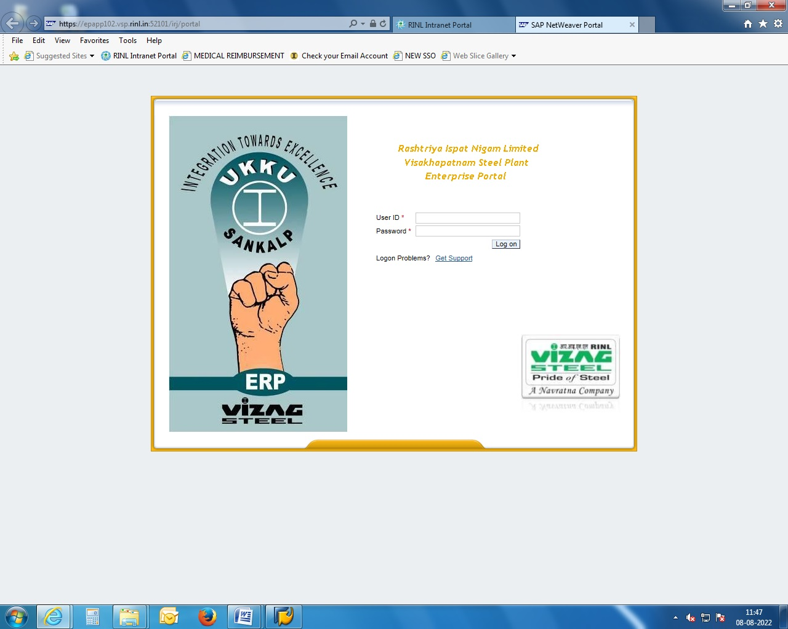  
***RAKE REGISTRATION & FEEDING***

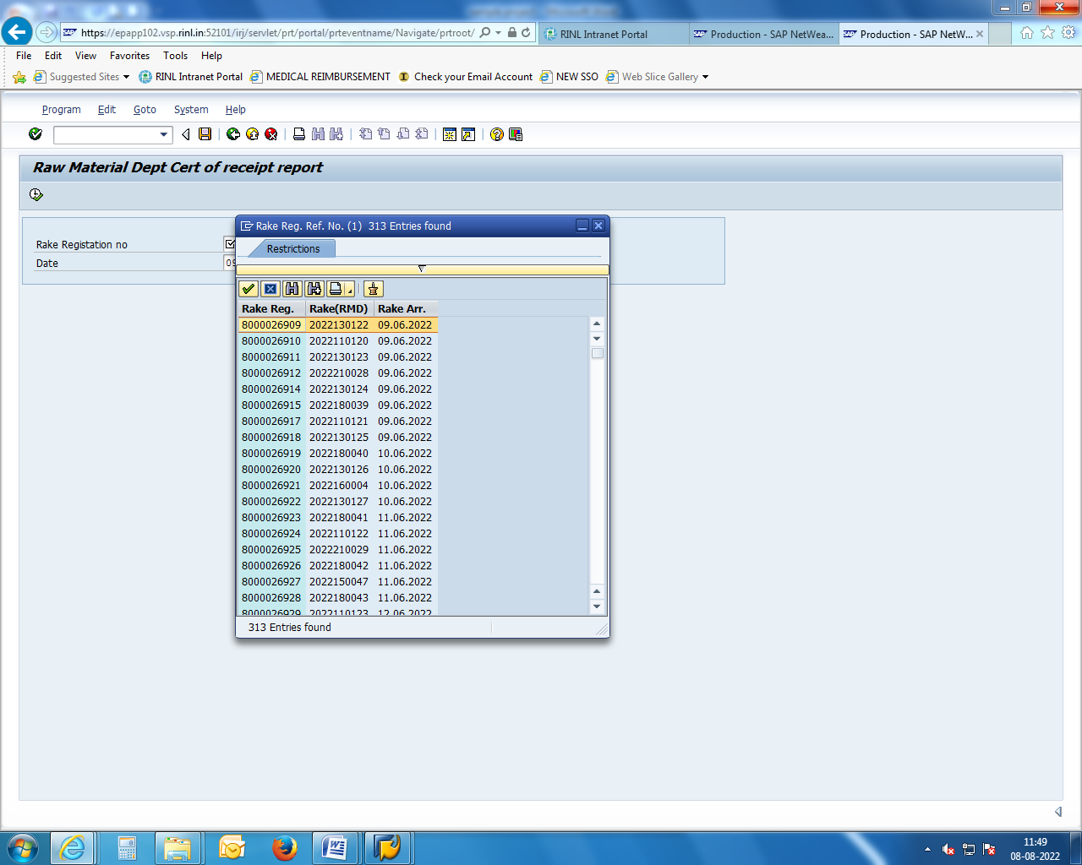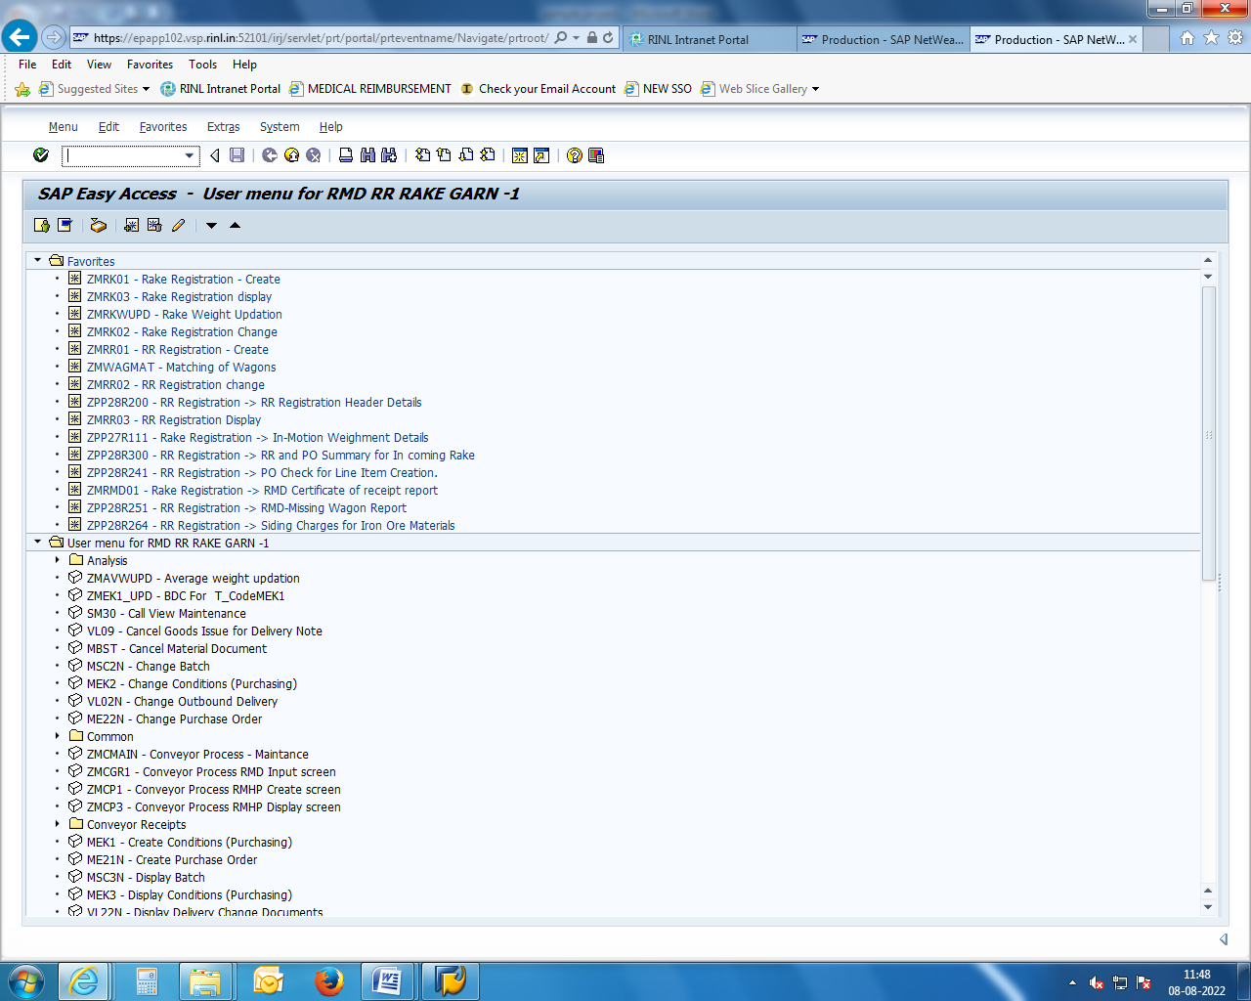

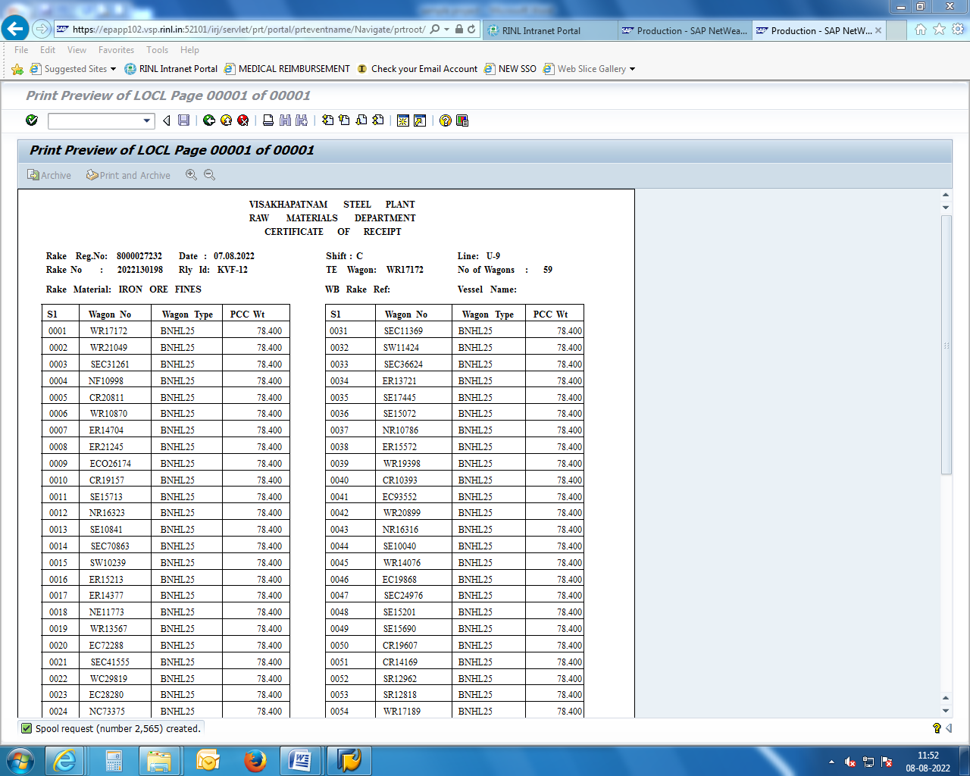

**SHIFT OFFICE ACTIVITIES**

* + Identification of materials by Rail / Road.
  + Received information on the rakes arrived.
  + Is to take down details of Raw material receipts preparation of COR’s (Certificate Of Receipts) and writing shift report and logbook.
  + Giving information to the department consult (Like plant controls, OCR,CCR,QATD etc…)
  + Monitoring shifting job Raw materials and stocks & assessing different materials stock.
  + Route allotment lines.
    - * Ore
      * Coal
  + Cross checking the loading information and daily report in case of required.
  + FOIS verification for the  rakes to be received in a particular shift.
  + And also consult the officer concerned materials information to
    - OCR - ORE (Control Room)
    - CCR - COAL (Control Room)
    - Ensure the recipes of coking coal and other raw materials with the interaction of RMHP & GPL.
    - Line No: U-4 to U-15 → ORE Tippling Room

U-25 to U-30 → COAL Tippling Room

* RAW Materials are stored in the bead of stock yards and ground hoppers/track hoppers.

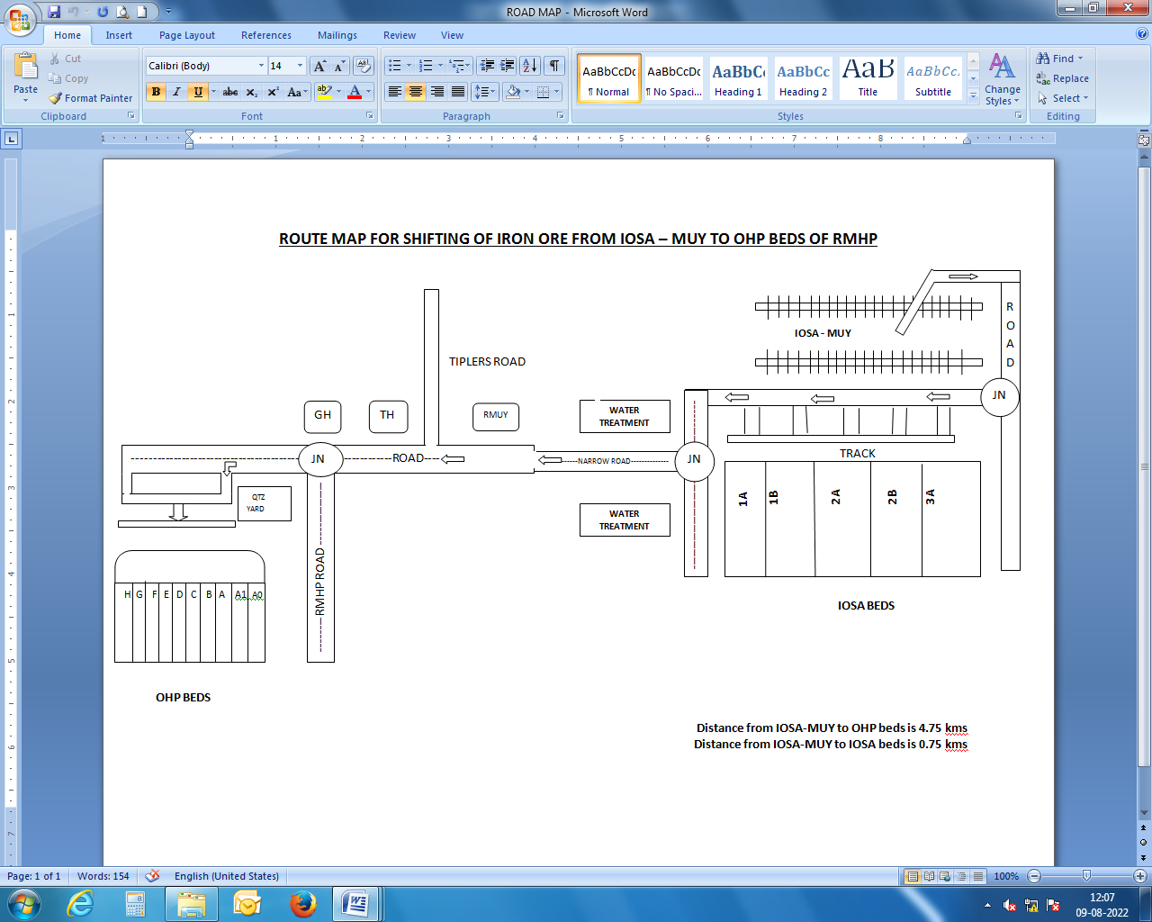

**Details of the particular RMD material code:**

* Iron Ore Fines(IOF) - 6013000
* Iron Ore Slime - 6013001
* Iron Ore Lump(IOL) - 6011000
* Iron Ore Pellets(IOP) - 6014000
* BF Lime Stones(BF L/S) - 6016000
* BF Dolomite(BF Dolo) - 6021000
* SMS LimeStones(SMS L/S) - 6018000
* SMS Dolomite(SMS Dolo) - 6022000
* Boiler Coal(BC) - 6006000
* BF Coke - 6096000
* BF Coke Import - 6097000
* Medium coking Coal(MCC) - 6002000
* Calibrated Lump Ore(CLO) - 6012000

**Details of the particular RMD Rake Numbers:**

* Iron Ore Fines(IOF) - 202213001
* Iron Ore Slime - 202212001
* Iron Ore Lump(IOL) - 202211001
* Iron Ore Pellets(IOP) - 202214001
* BF Lime Stones(BF L/S) - 202216001
* BF Dolomite(BF Dolo) - 202221001
* SMS LimeStones(SMS L/S) - 202218001
* SMS Dolomite(SMS Dolo) - 202222001
* Boiler Coal(BC) - 202206001
* BF Coke - 202296001
* BF Coke Import - 202297001
* Medium coking Coal(MCC) - 202202001
* Calibrated Lump Ore(CLO) - 202212001

**Accounting of Raw Materials:**

* Accounting of all raw materials received by rail and road are done on a monthly basis by the individual sections which are coal section, ore section, flux section and road materials section.
* Wagon booked vide Railway Receipts (RR’s) - are tallied with certificate of receipt GRNs are prepared for the wagons received and sent to the finance department.

**Role and Importance of RMD:**

RMD is playing the most critical and responsible role in the Visakhapatnam Steel Plant. The aim of RMD is to procure raw materials required for steel production in the right quantity by the right time at the right cost.

**Role of RMD:**

* Maintaining uninterrupted flow of raw materials.
* Buying at competitive prices.
* Avoiding under inventory and Ores inventory.
* To have good relationships with other departments.
* RMD personnel need vast study of maked and redistic level of planning.

|  |  |  |
| --- | --- | --- |
| **MATERIAL** | **SUPPLIER** | **SOURCE** |
| BC (Boiler Coal) | M/s MCL | Talcher |
| M/s MCL | BOCM/LOCM |
| M/s SCCL | Singareni |
| MCC  (Medium Coking Coal) | M/s CCL | RAJARAPPA / KEDLA / SWANG |
| M/s BCCL | Patherdih |
| PCC (Prime Coking Coal) | M/s BCCL | Munidih |
| IOF(Iron Ore Fines) | M/s NMDC,  Bailadilla Mines | NMDB, NMVK |
| M/s NMDC, | RNJP |
| M/s OMC | DAITARI |
| IOL(Iron Ore Lump) | M/s NMDC,  Bailadilla Mines | NMDB, NMVK |
| CLO  (Calibrated Lump Ore) | M/s NMDC,  Bailadilla Mines | NMDB, NMVK |
| M/s NMDC, | RNJP |
| BF Limestone | Captive Mines | JAGGAYYAPETA |
| SMS Limestone | Private Party | UAE, Dubai |
| BF Dolomite | Captive Mines | Madharam |
| Private Party | Birmitrapur (BRMP)  Belha (BYL) |
| SMS Dolomite | Captive Mines | Madharam |
| Private Party | Birmitrapur (BRMP)  Belha (BYL)  Baradwar(BUA) |
| QUARTZ LUMP | Private Party | - |
| Captive Mines | Kintada |
| QUARTZ FINES | Private Party | - |
| Mn. Ore Fines | Captive Mines | Garbham,  Manganese Mine |
| MN ORE LUMP | Captive Mines | Garbham,  Manganese Mine |
| M/s MOIL | Maharastra |
| SAND | Captive Mines | Sarepalli |

Imported Coking Coals:

**I.C.C –Hard Coals:**

|  |  |
| --- | --- |
| I.C.C - Peakdown | Australia to GPL |
| I.C.C - Goonyella |
| I.C.C - Moranbha North |
| I.C.C - Cambria Creek | USA to GPL |
| I.C.C - Benga PHCC | Mozambique to GPL |
| I.C.C - Tuhup (Indonesia) | Indonesia to GPL |

**I.C.C – Soft Coals:**

|  |  |
| --- | --- |
| I.S.C - BWS | Australia to GPL |
| I.S.C – Blue Diamond Soft | USA to GPL |
| I.S.C – Kestrel | Australia to GPL |
| I.S.C – Moura Soft |
| PCI |
| Iron Ore Fines | Bacheli, Kirandul, KIOCL(GPL), SAIL(BXF), OMC(Daltari), RNJP(DIOM), OMDC(Barblil) |

**FLOW OF WORK (RMD):**

* Users departments give consumption plan to plant control.
* Plant control gives the requirement to RMD.
* RMD raises PR and Sent to MM(Material Management).
* The MM department Raises te supplier based on the TR which is received for RMD.
* Received quotations will be sent to RMD for TR (Technical Recommendation).
* The MM department finalizes the supplier for TR from RMD.
* Commercial aspects are to be taken care of by RMD with railways.
* Transfer/Transport activities are to be taken care of by the traffic department.

**Specific Consumption of Raw Materials:**

* **( Per Tonne of Hot Metal )**
  + - Sinter → 1287 kg
    - IOS → 347 kg
* **Fuel:**
  + Coke → 534 kg
  + Nut Coke → 9 kg
  + PCI → 15.5 kg

**558 kg**

For 6.3 MT(Metric Tonne) Production 24 MT Of Raw Material required.

|  |  |
| --- | --- |
| **Constituent** | **Chemical Formula** |
| Iron Ore | Hematite (Fe2O3) |
| Limestone | CaCo3 |
| Dolomite | (SiO2) MgCo3 |
| Coke | Carbon |

**Iron Ore Chemical Composition:**

* + - % Fe     → 63 to 65 %
    - % Sio2 → 1.5 % Max
    - %Al2O3 → 1.2 % Max
    - % P → 0.06 %
    - % S → 0.02 %
* **Hot Metal Statistics:**

|  |  |  |  |
| --- | --- | --- | --- |
| **YEAR** | **PLAN** | **ACTUAL** | **FULFILLMENT** |
| 2018-19 | 6.2 MT | 5.77 MT | 93 % |
| 2019-20 | 6.5 MT | 5.16 MT | 79 % |
| 2020-21 | 6.1 MT | 4.68 MT | 77 % |
| 2021-22 | 6.25MT | 5.77 MT | 92 % |
| 2022-23  (till July’22) | 6.1 MT | *1.38MT | - |

**Note:** * Up to Apr-Jul’22

**Liquid Steel Statistics:**

|  |  |  |  |
| --- | --- | --- | --- |
| **YEAR** | **PLAN** | **ACTUAL** | **FULFILLMENT** |
| 2018-19 | 6.1 MT | 5.52 MT | 90 % |
| 2019-20 | 6.4 MT | 4.98 MT | 78 % |
| 2020-21 | 5.9 MT | 4.49 MT | 76 % |
| 2021-22 | 6.10 MT | 5.51 MT | 90 % |
| 2022-23  (till July’22) | 6.3 MT | *1.59 MT | - |

**Note:** * Up to Apr-Jul’22

|  |  |  |
| --- | --- | --- |
| **Material** | **Source** | **Supplier** |
| Iron Ore Fines | Bacheli / Kirandul (Chhattisgarh) | NMDC (National Mineral Development Corporation) |
| Iron Ore Lump | Bacheli / Kirandul | NMDC |
| Calibrated Lump Ore (Sized Ore) | Kirandul | NMDC |
| IOP (Iron Ore Pellets) | Raipur | GPIL (Godavari Power ispat Limited)  KIOCL (Kudremukh Iron Ore Company Limited)  NMDC (Kumaraswami, Donimalai) |

**SPECIFICATIONS OF IRON ORE**

**Iron Ore Lump (IOL):**

* + - TFe → 65.5% Min
    - Al2O3 → 2.25% Max
    - SiO2 → 2.25% Max
    - Phosphorus → 0.075% Max
    - Sulfur → 0.040% Max
    - Size → 10-150 mm

**Iron Ore Fines (IOF):**

* TFe → 64.5% Min
* Al2O3 → 3.0% Max
* SiO2 → 3.0% Max
* Phosphorus → 0.075% Max
* Sulfur → 0.040% Max
* Size → 10 mm

**Iron Ore Sized (IOS/CLO):**

* + TFe → 65% Min
  + Al2O3 → 3.0% Max
  + SiO2 → 3.0 Max
  + Phosphorus → 0.075 Max
  + Sulfur → 0.040 Max
  + Size → 10-30 mm

**Iron Ores:**

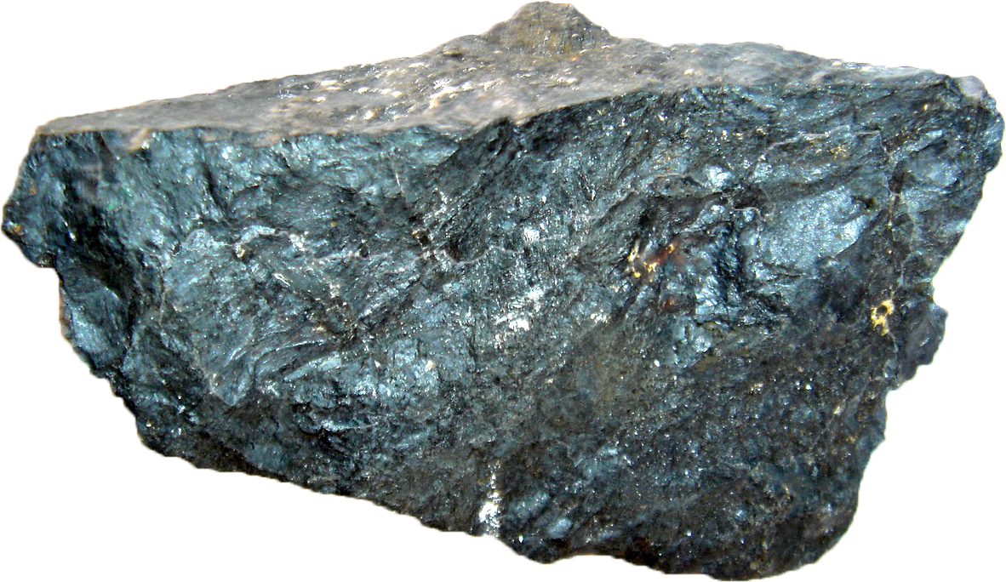

Iron Ores are rocks and minerals from which metallic iron can be economically extracted. The ores are usually rich in iron oxides and vary in color from dark gray, bright yellow, deep purple, to rusty red. The iron itself is usually found in the form of magnetic (Fe3O4), Hematite (Fe2O3), Goethit (Feo(OH)), Limonite (feo(OH)), Siderite (FeCo3).

**Chemical Composition:**

* + - %Fe → 63 - 65% Min
    - %Al2O3 → 3.0% Max
    - %SiO2 → 3.0 Max
    - Phosphorus → 0.06 Max
    - Sulfur → 0.02 Max

**Ores:**

Ores of iron bearing materials are iron ore and manganese ore, Manganese ore lump.

The main source of iron input  is from iron ore the hematite type of ore is used in the process of iron making. The iron content in the ore is present in the form of oxide. Which is reduced iron and the blast furnace by using coke and flux materials.

* **Raw Materials Bins (RMB):**

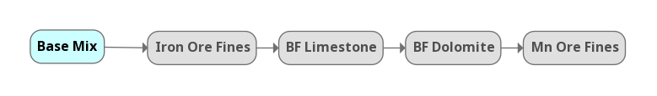

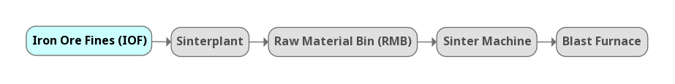

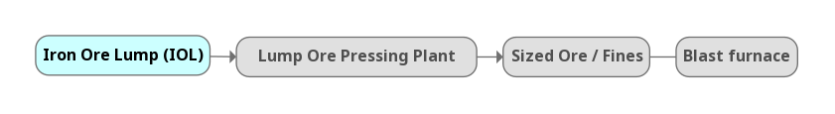

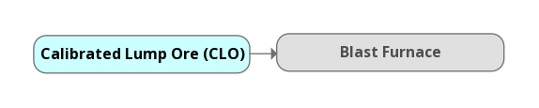

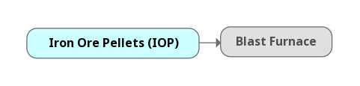

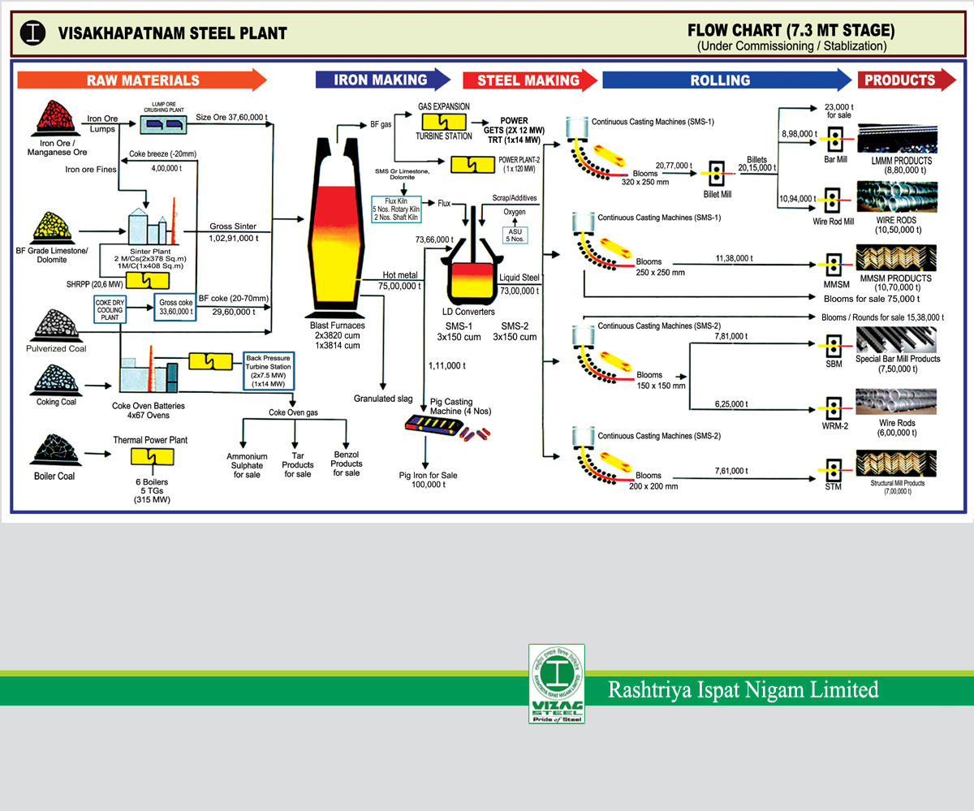

**MAJOR RAW MATERIALS**

* Raw Materials are mainly classified as below.

1. Ores.
2. Coals.
3. Fluxes.
4. **Ores:**

They are Two Types

* + 1. Iron Ores
    2. Manganese Ores

**Iron Ores:**

They are 4 Types

1. Iron Ore Lump
2. Iron Ore Fines
3. Calibrated Lump Ore (CLO / Sized Ore)
4. Slime Ore Fines
5. **Coals:**

They are Two Types.

* + 1. Non Coking Coal (Boiler Coal)
    2. Coking coal (3 Types)
  1. Prime Coking Coal (PCC)
  2. Medium Coking Coal (MCC)
  3. Imported Coking Coal (ICC)

1. **Fluxes:**

The fluxes are used in the process to remove the impurities in the iron ore which are known as gangue and mainly in the form of Al2O3 & SiO2 the fluxes combine with gangue to form the slag and separate from hot metal /steel.

They are Two Types

* + 1. Dolomite (Mgo)
    2. Limestone (Cao)

Fluxes    → BF LimeStone / Dolomite

→SMS Limestone / Dolomite

These fluxes are Limestone, Dolomite, Quartzite and River Sand.

**1. DOLOMITE:**

They are Two Types

1. BF Grade Dolomite (Blast Furnace)
2. SMS Grade LimeStone (Steel Melting Shop)

* **Siding:**
* SAIK → BF Dolomite → Madharam (RINL Captive)

→ SMS Dolomite

* MGPV → Gangavaram Port Limited →UAE

(United Arub Emirates)

(GPL Rake → SMS Limestone)

* RVSJ → JPTN → BF Limestone (RINL Captive)
* Dolomite → Dolomite is a carbonite
  + Mineral composed of calcium, magnesium, carbonate Camg (Co3)2.
* **Chemical Composition:**
* **BF Grade Dolomite:**
  + Cao → 28-30%
  + Mgo → 18-21%
  + Sio2 → 02-04%
  + Size → 06-80mm
* **SMS Grade Dolomite:**
  + Cao → 29% Min
  + Mgo → 19-21%
  + Sio2 → 01-02%
  + Size → 25-50mm
* **STEEL MAKING:**

**Formula:**

* **(Fe2O3) + Coal ( c ) → Fe2c  +  Co2↑**

(Iron Ore) (Carbon) (Carbon Dioxide)

Content (Carbon monoxide)

Heat Source in BF

* 1 Ton of Hot Metal = 1.6 Raw Materials Required.
* 1 Ton of Liquid Steel Required Raw Material = 1.15 Hot Metal Required.
* **Base Mix:**
  + 1.6 Ton of Raw Materials
  + 1 Ton of base mix for IOF
  + 0.7 ton of IOF
* **Sinter:**
  + 1.1 ton of base mix
* **Hot Metal:**
  + 1.47 ton of sinter

**MINOR RAW MATERIALS**

(Road Materials)

1. Sand
2. Quartzite Lump
3. Quartzite Fines
4. Manganese Ore Fines
5. Manganese Ore Lump

**SUPPLIERS**

**NMDC (National Mineral Development Corporation)**

**Iron Ore:**

* Head Office → Hyderabad
* Mines → Chhattisgarh,Kirandul, Bacheli, Bailadela

Karnataka, Rinjitpura, Kumaraswami, Donimalai.

**Coals:**

* Boiler Coal → Singareni (Telangana)
* Imported Boiler Coal → Indonesia

Orissa

Talcher.

**MCC:**

* Medium Coking Coal → Jharkhand

(Kedla, Rajarappa, Kathara).

**ICC:**

Imported Coking Coal →Australia, US (United States), NewZealand.

**Fluxes:**

* Dolomite → Telangana (Madharam) →Captive Mines

Orissa →Chhattisgarh → Private Mines

* SMS Dolomite → Madharam (Captive)

Chhattisgarh (Private) Belha, Bua.

**B. LIMESTONE:**

They are Two Types

* BF Grade Limestone → Jaggayyapeta (Vijayawada)
* SMS Grade Limestone → Imported

**Transporting Material in RINL:**

There are 3 Types of Transport Ways

1. Road
2. Rail
3. Sea

**(GPL) GANGAVARAM PORT LIMITED**

* ICC (Imported Coking Coal) Transferred to Conveyor GPL to VSP.
* SMS Limestone is supplied through Rakes from GPL to VSP.

**4.ABREVIATIONS FOR RAW MATERIAL DEPARTMENT**

* IOF → Iron Ore Fines
* IOL → Iron Ore Lump
* IOS → Iron Ore Sized
* RR → Railway Receipt
* COR → Certificate of Receipt
* GRN → Goods Receipt Note
* OMC → Odisha Mining Corporation
* DATR → Daitari
* NMDC → National Mineral Development Corporation
* RNJP → Daitari
* CLO → Calibrated Lump Ore
* MCC → Medium Coking Coal
* BC → Boiler Coal
* CTC → Central Traffic Control
* ICC → Imported Coking Coal
* HCC → Hard Coking Coal
* SCC → Soft Coking Coal
* PCI → Pulverized Coal Injection
* GPL → Gangavaram Port Limited
* OT → Ore Tippler
* CT → Coal Tippler
* IBC → Imported Boiler Coal
* SAP → Systems Applications & Products
* FAUC → Freight Adjustment Under Chargers
* POL → Punitive Over Load
* GST → Goods & Service Tax
* DS → Delevement Surcharge
* BPO → Business Process Outsourcing
* ERP → Enterprises Resource Planning
* RMJC → Rungta Mines
* NMET → National Mineral Exploration Trust (2% Of Royalty)
* DMF → District Mineral Fund (30% Royalty)
* FOIS → Freight Operations Information System
* GV → Guards Voucher
* OPT → Operating Paticulations Transit
* PCC → Permissible Carrier Capacity
* MN → Moranbah North
* ROM → Run Of Mines
* PD → Peak Downs
* CC → Cambria Crick
* BPHCC → Benga Premium Hard Coking Coal
* BWS → Black Water Soft
* NZSS → Newzealand Semi Soft
* IOF → Iron Ore Fines
* IOL → Iron Ore Lump
* SMS → Steel Melting Shop
* BF → Blast Furnace
* CLO → Calibrated Lump Ore
* QF → Quartz Fines
* MnO → Manganese Ore
* SP → Sinter Plant
* IOS → Iron Ore Slime
* IOP → Iron Ore Pellets
* RMHP → Raw Material Handling Plant
* ISC → Imported Soft Coal

***4.RAW MATERIAL DEPARTMENT USING IN HTML PROGRAMME***

***HTML:***

HTML (HyperText Markup Language) is the most basic building block of the Web. It defines the meaning and structure of web content. Other technologies besides HTML are generally used to describe a web page's appearance/presentation (CSS) or functionality/behavior (JavaScript).

**Web Designing Programme Frent view**

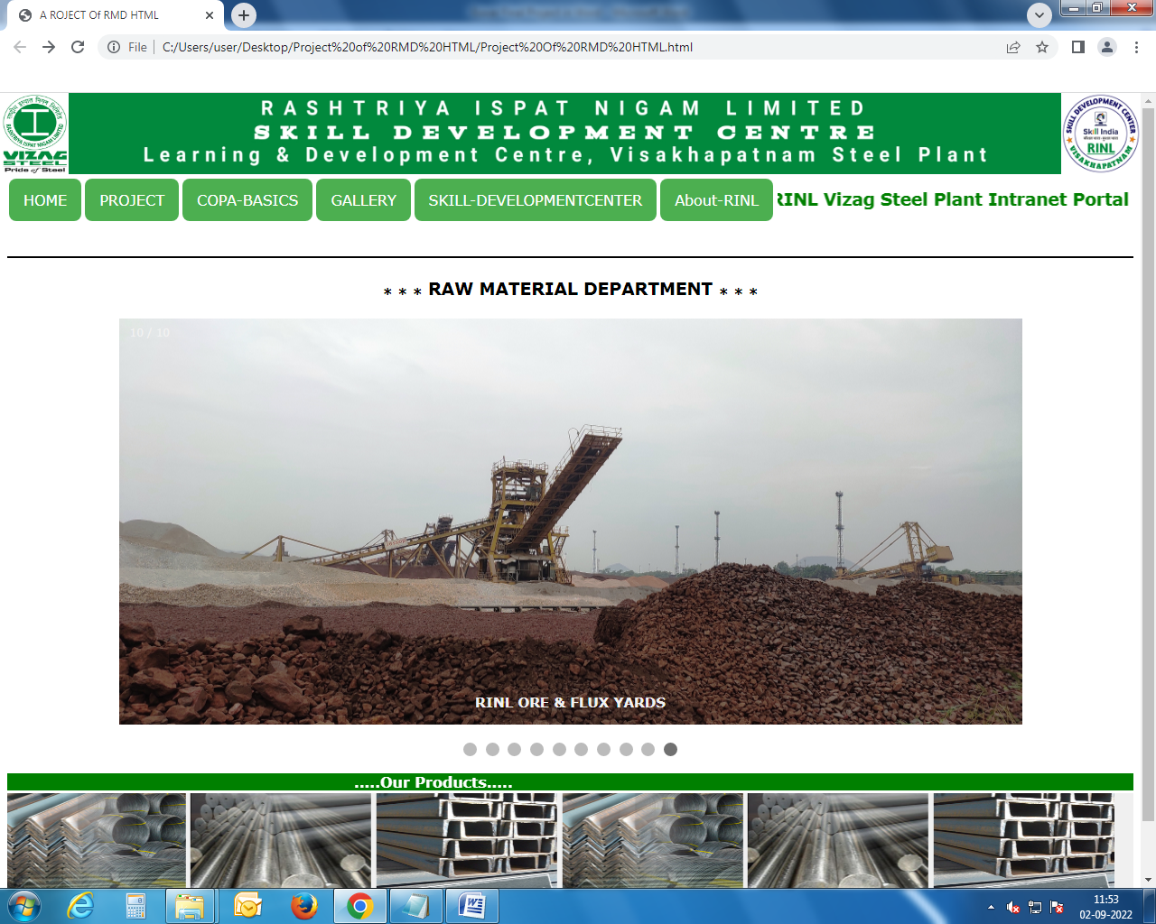

**Project Menu drop Down:**

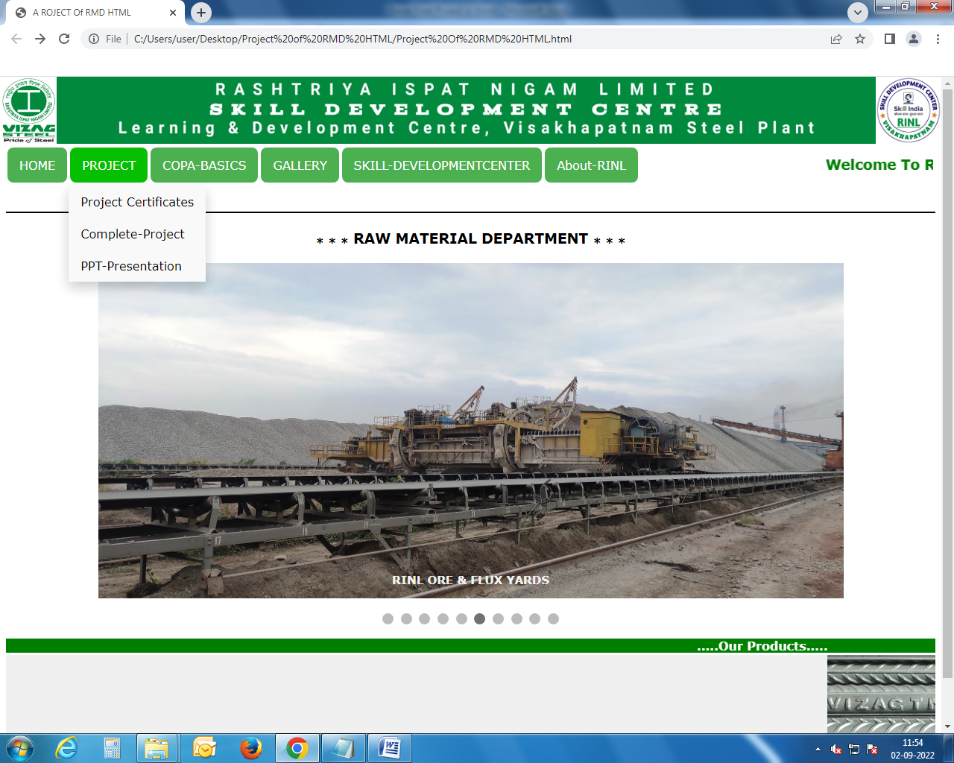

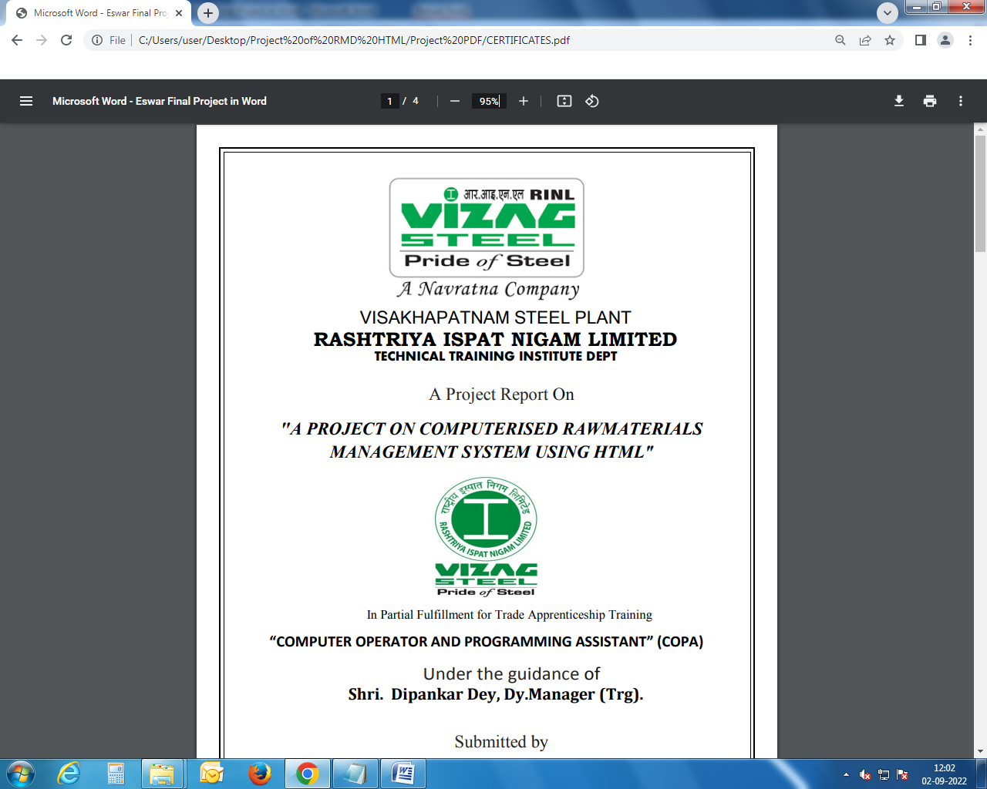

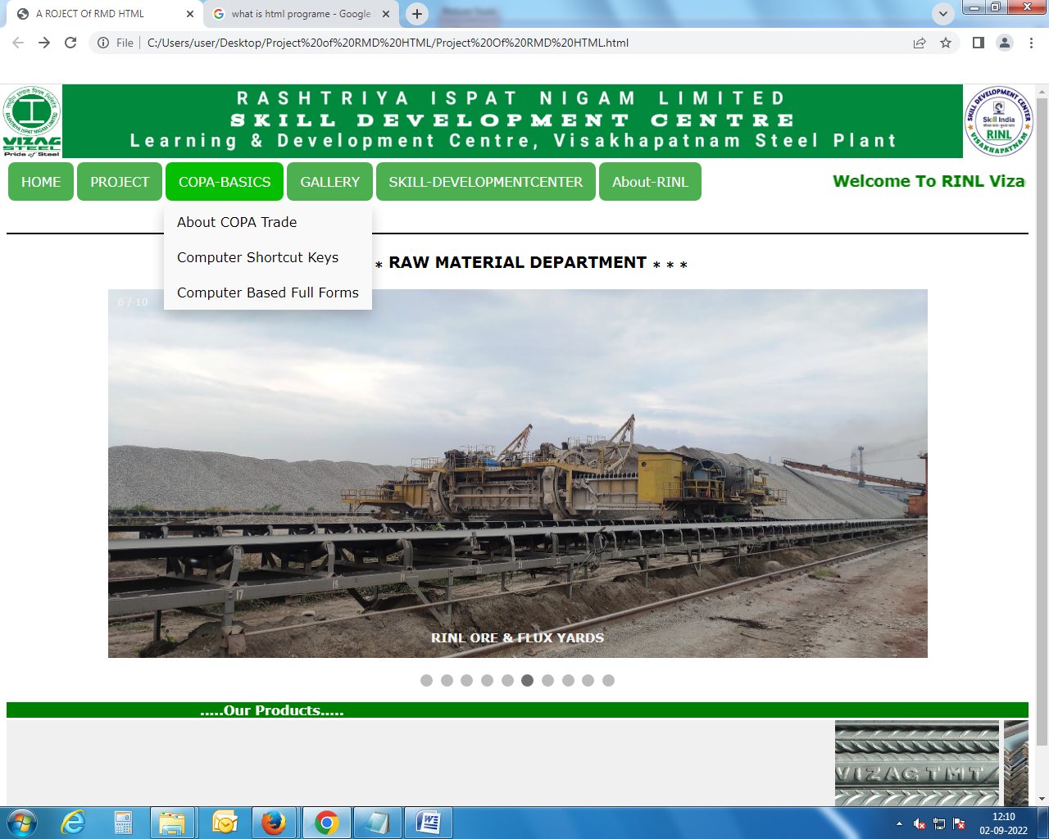**COPA BASICS DROPDOWN :**

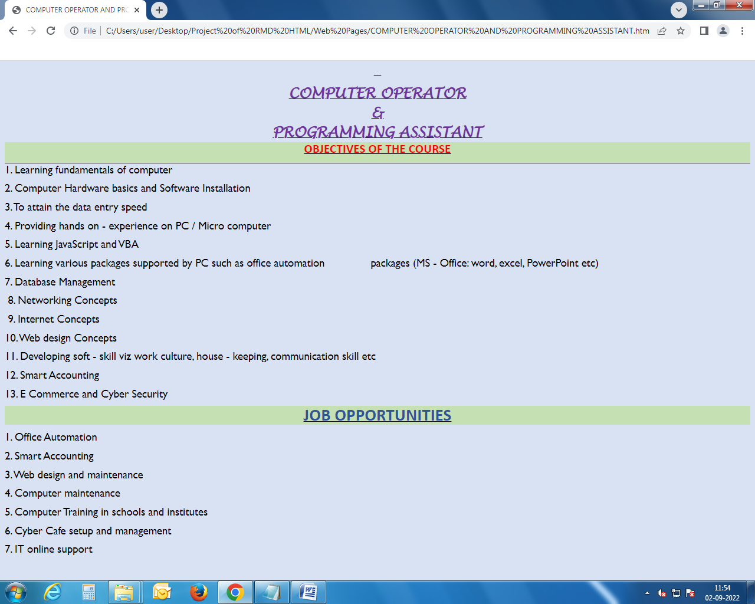

**RAW MATERIALS GALLERY DROPDOWN:**

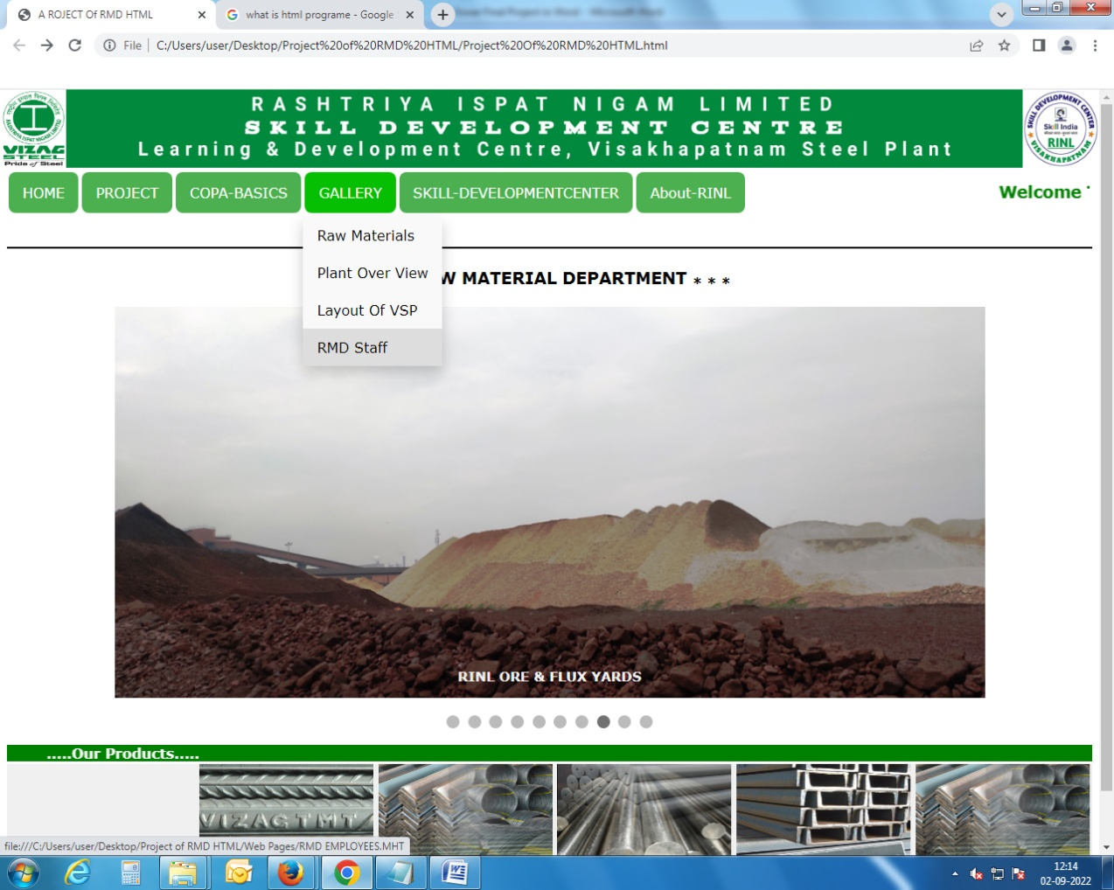

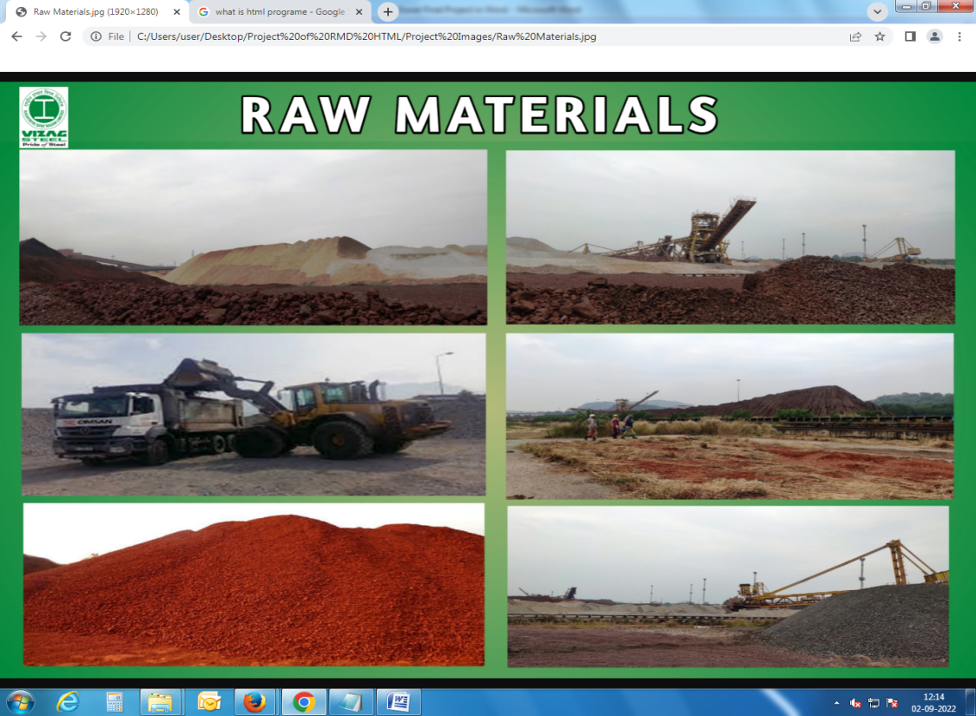

**SOURCE CODE FOR**

***RAW MATERIAL DEPARTMENT USING IN HTML PROGRAMME***

<!DOCTYPE html>

<html>

<head>

<title>A ROJECT Of RMD HTML</title>

<body>

<img src="C:\Users\user\Desktop\Project of RMD HTML\Project Images\RINL-

Banner.jpg"width="100%"height="90"style="width:100%;position:absolute;top:0;left:0"<\img>

<img src="C:\Users\user\Desktop\Project of RMD HTML\Project Images\RINL-

Logo.jpeg"width="50"height="90"style="width:6%;position:absolute;top:0;left:0"<\img>

<img src="C:\Users\user\Desktop\Project of RMD HTML\Project Images\SDC-LOGO1.jpg" height="90"style="width:7%;position:absolute;top:0;right:0"<\img>

</body>

<iframe src="/default.asp" width="100%" height="80" style="border:1px solid black;"> </iframe>

<link rel="stylesheet"href="Project Of RMD HTML.css">

<body>

<p1>

<div class="HOME">

<button class="dropbtn">HOME

<i class="fa fa-caret-down"></i>

</button>

<div class="PROJECT-content">

</div>

</div>

</p1>

<p2>

<div class="PROJECT">

<button class="dropbtn">PROJECT

<i class="fa fa-caret-down"></i>

</button>

<div class="PROJECT-content">

<a href="C:\Users\user\Desktop\Project of RMD HTML\Project PDF\CERTIFICATES.pdf" class="nav-item nav-link">Project Certificates</a>

<a href="C:\Users\user\Desktop\Project of RMD HTML\Project PDF\Eswar Final Project in PDF.pdf" class="nav-item nav-link">Complete-Project</a>

<a href="C:\Users\user\Desktop\Project of RMD HTML\Project PDF\PPT-Presentation.pdf" class="nav-item nav-link">PPT-Presentation</a>

</div>

</div>

</p2>

<p3>

<div class="COPA-BASICS">

<button class="dropbtn">COPA-BASICS

<i class="fa fa-caret-down"></i>

</button>

<div class="COPA-BASICS-content">

<a href="C:\Users\user\Desktop\Project of RMD HTML\Web Pages\COMPUTER OPERATOR AND PROGRAMMING ASSISTANT.htm" class="nav-item nav-link">About COPA

Trade</a>

<a href="C:\Users\user\Desktop\Project of RMD HTML\Web Pages\Basic_Computer_Shortcut_Keys_A_to_Z.htm" class="nav-item nav-link">Computer Shortcut

Keys</a>

<a href="C:\Users\user\Desktop\Project of RMD HTML\Web Pages\COMPUTER BASED FULL FORMS.htm" class="nav-item nav-link">Computer Based Full Forms</a>

</div>

</div>

</p3>

<p4>

<div class="GALLERY">

<button class="dropbtn">GALLERY

<i class="fa fa-caret-down"></i>

</button>

<div class="GALLERY-content">

<a href="C:\Users\user\Desktop\Project of RMD HTML\Project Images\Raw Materials.jpg" class="nav-item nav-link">Raw Materials</a>

<a href="C:\Users\user\Desktop\Project of RMD HTML\Project Images\7.3 MT stage.jpg" class="nav-item nav-link">Plant Over View</a>

<a href="C:\Users\user\Desktop\Project of RMD HTML\Project Images\LAYOUT_OF_VSP_RMD.jpg" class="nav-item nav-link">Layout Of VSP</a>

<a href="C:\Users\user\Desktop\Project of RMD HTML\Web Pages\RMD EMPLOYEES.MHT" class="nav-item nav-link">RMD Staff</a>

</div>

</div>

</p4>

<p5>

<div class="SKILL-DEVELOPMENTCENTER">

<button class="dropbtn">SKILL-DEVELOPMENTCENTER

<i class="fa fa-caret-down"></i>

</button>

<div class="SKILL-DEVELOPMENTCENTER-content">

<a href="C:\Users\user\Desktop\Project of RMD HTML\Web Pages\Training-and-skills.HTM" class="nav-item nav-link">Training & Skills</a>

<a href="C:\Users\user\Desktop\Project of RMD HTML\Web Pages\L & DC Employees.HTM" class="nav-item nav-link">SDC-Managers</a>

</div>

</div>

</p5>

<p6>

<div class="About-RINL">

<button class="dropbtn">About-RINL

<i class="fa fa-caret-down"></i>

</button>

<div class="About-RINL-content">

<a href="C:\Users\user\Desktop\Project of RMD HTML\Web Pages\Introduction to Visakhapatnam Steel Plant.htm" class="nav-item nav-link">Plant

Introduction</a>

<a href="https://rinl.onlineregistrationforms.com/#/home" class="nav-item nav-link">Notification</a>

<a href="C:\Users\user\Desktop\Project of RMD HTML\Project PDF\CMD-Message.pdf" class="nav-item nav-link">Chairman's Desk</a>

</div>

</div>

</p6>

<table>

<tr>

<th><marquee><font color="Green"><sub><sub><sub><h1>Welcome To RINL Vizag Steel Plant Intranet Portal</h1></sub></sub></sub></marquee></th>

</tr>

</table>

<br>

<iframe src="/default.asp" width="100%" height="0.1" style="border:1px solid black;"></iframe>

<style>

h3 {

text-align: center;

}

</style>

<h3><b><sub>* * *</sub> RAW MATERIAL DEPARTMENT <sub>* * *</sub></b></h3>

<body>

<div class="slideshow-container">

<div class="mySlides fade">

<video style="width:100%" width="300" height="450" autoplay loop muted>

<source src="C:\Users\user\Desktop\Project of RMD HTML\Project Images\RINL-VID.mp4" type="video/mp4" />

</div>

<div class="mySlides fade">

<div class="numbertext">2 / 10</div>

<img src="C:\Users\user\Desktop\Project of RMD HTML\Project Images\PP_Gate.jpg" style="width:100%" width="300" height="450">

<div class="text"><b>Plant Plaza Gate</b></div>

</div>

<div class="mySlides fade">

<div class="numbertext">3 / 10</div>

<img src="C:\Users\user\Desktop\Project of RMD HTML\Project Images\Steel_Plant_View.jpeg" style="width:100%" width="300" height="450">

<div class="text"><b>Steel Plant Over View</b></div>

</div>

<div class="mySlides fade">

<div class="numbertext">4 / 10</div>

<img src="C:\Users\user\Desktop\Project of RMD HTML\Project Images\Welcome_Gate.jpg" style="width:100%" width="300" height="450">

<div class="text"><b>Welcome Steel Plant Township Arch</b></div>

</div>

<div class="mySlides fade">

<div class="numbertext">5 / 10</div>

<img src="C:\Users\user\Desktop\Project of RMD HTML\Project Images\COAL.jpg" style="width:100%" width="300" height="450">

<div class="text"><b>RINL COAL YARDS</b></div>

</div>

<div class="mySlides fade">

<div class="numbertext">6 / 10</div>

<img src="C:\Users\user\Desktop\Project of RMD HTML\Project Images\RMD-Yards (2).jpg" style="width:100%" width="300" height="450">

<div class="text"><b>RINL ORE & FLUX YARDS</b></div>

</div>

<div class="mySlides fade">

<div class="numbertext">7 / 10</div>

<img src="C:\Users\user\Desktop\Project of RMD HTML\Project Images\RMD-Yards (3).jpg" style="width:100%" width="300" height="450">

<div class="text"><b>RINL ORE & FLUX YARDS</b></div>

</div>

<div class="mySlides fade">

<div class="numbertext">8 / 10</div>

<img src="C:\Users\user\Desktop\Project of RMD HTML\Project Images\RMD-Yards (4).jpg" style="width:100%" width="300" height="450">

<div class="text"><b>RINL ORE & FLUX YARDS</b></div>

</div>

<div class="mySlides fade">

<div class="numbertext">9 / 10</div>

<img src="C:\Users\user\Desktop\Project of RMD HTML\Project Images\RMD-Yards (5).jpg" style="width:100%" width="300" height="450">

<div class="text"><b>RINL ORE & FLUX YARDS</b></div>

</div>

<div class="mySlides fade">

<div class="numbertext">10 / 10</div>

<img src="C:\Users\user\Desktop\Project of RMD HTML\Project Images\RMD-Yards (6).jpg" style="width:100%" width="300" height="450">

<div class="text"><b>RINL ORE & FLUX YARDS</b></div>

</div>

</div>

<br>

<div style="text-align:center">

<span class="dot"></span>

<span class="dot"></span>

<span class="dot"></span>

<span class="dot"></span>

<span class="dot"></span>

<span class="dot"></span>

<span class="dot"></span>

<span class="dot"></span>

<span class="dot"></span>

<span class="dot"></span>

</div>

</body>

<script>

let slideIndex = 0;

showSlides();

function showSlides() {

let i;

let slides = document.getElementsByClassName("mySlides");

let dots = document.getElementsByClassName("dot");

for (i = 0; i < slides.length; i++) {

slides[i].style.display = "none";

}

slideIndex++;

if (slideIndex > slides.length) {slideIndex = 1}

for (i = 0; i < dots.length; i++) {

dots[i].className = dots[i].className.replace(" active", "");

}

slides[slideIndex-1].style.display = "block";

dots[slideIndex-1].className += " active";

setTimeout(showSlides, 6010); // Change image every 2 seconds

}

</script>

<p>

<marquee bgcolor="green" behavior="alternate"><font color="white"><b>.....Our Products.....</b></font></marquee>

<body color="c0c0c0">

<marquee behavior="right" bgcolor="f0f0f0">

<img src="C:\Users\user\Desktop\Project of RMD HTML\Project Images\rebars.jpg"

width="200" height="150" alt="Bouncing ball"></img>

<img src="C:\Users\user\Desktop\Project of RMD HTML\Project Images\exports.jpg"

width="200" height="150" alt="Bouncing ball"></img>

<img src="C:\Users\user\Desktop\Project of RMD HTML\Project Images\forged_rounds.jpg"

width="200" height="150" alt="Bouncing ball"></img>

<img src="C:\Users\user\Desktop\Project of RMD HTML\Project Images\structurals.jpg"

width="200" height="150" alt="Bouncing ball"></img>

<img src="C:\Users\user\Desktop\Project of RMD HTML\Project Images\exports.jpg"

width="200" height="150" alt="Bouncing ball"></img>

<img src="C:\Users\user\Desktop\Project of RMD HTML\Project Images\forged_rounds.jpg"

width="200" height="150" alt="Bouncing ball"></img>

<img src="C:\Users\user\Desktop\Project of RMD HTML\Project Images\structurals.jpg"

width="200" height="150" alt="Bouncing ball"></img>

</body>

</marquee>

</body>

</p>

</head>

</html>



**CONCLUSION & DISCUSSION**

Raw Materials is the backbone of steel industry is one of the most sought after metal and plays a vital role in the economy of a country. The Raw materials required for Iron ore is the most important and basic Raw materials of the iron and steel industry. It takes about 1.5 tonnes of iron ore to make a ton of pig- iron. The most important Fuel are Coal and Coke.

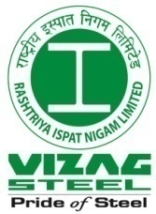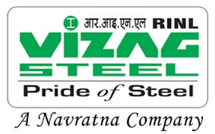

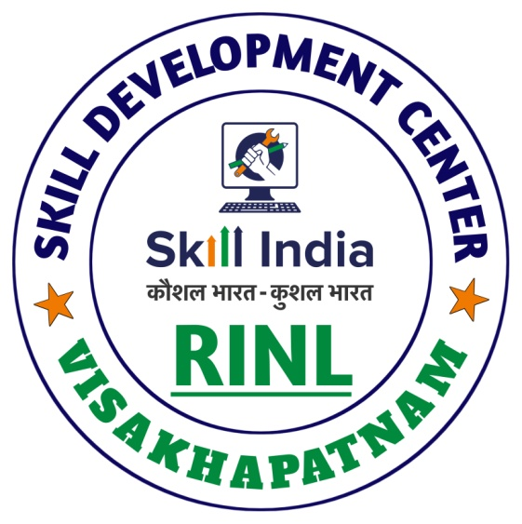

***THANK YOU***